**Bright spots of coral resilience on the Great Barrier Reef**

**Mellin C, Matthews S, Anthony K, Brown S, Caley MJ, Fordham DA, Johns K, Osborne K, Puotinen M, Thompson A, Wolff N, MacNeil MA**

**Supplemental Experimental Procedures**

**Surveyed reefs**

Australia’s Great Barrier Reef (GBR) consists of more than 2,900 individual reefs extending over 2,300 km between 9 and 24°S latitude. Reef communities of the GBR have been monitored yearly between 1993 and 2005, and then biennially thereafter, by the Australian Institute of Marine Science’s (AIMS) Long-Term Monitoring Program (LTMP) (1). As part of the LTMP, a total of 46 reefs were monitored for transect-based benthic covers between 1996 and 2015 in six latitudinal sectors (Cooktown-Lizard Island, Cairns, Townsville, Whitsunday, Swain and Capricorn-Bunker) spanning 150,000km2 of the GBR. In each sector (with the exception of the Swain and Capricorn-Bunker sectors) at least two reefs were sampled in each of three shelf positions (i.e., inner, mid- and outer).

An additional dataset was collected by the manta-tow technique and included 97 reefs surveyed in 1996 and thereafter (44 of those being also surveyed for transect-based benthic cover) and encompassed within the same study region. We used the more detailed transect-based information available for 46 reefs to calibrate the model, and the additional manta-tow data available for 97 reefs to validate it (with a particular focus on the reefs that were not used for model calibration) (Fig. S9).

**Survey methods and data collection**

Transect-based data on benthic assemblages were collected at three sites separated by > 50 m within a single habitat on the reef slope (the first stretch of continuous reef on the northeast flank of the reef, excluding vertical drop-offs). Within each site, five permanently marked 50-m long transects were deployed parallel to the reef crest, each separated by 10-40 m along the 6-9 m depth contour. Percentage cover of benthic categories were estimated for each transect using point sampling of a randomly selected sequence of images (2). The benthic organisms under five points arranged in a quincunx pattern in each image were identified to the finest taxonomic resolution possible (n = 200 points per transect) and the data were converted to percent cover. In this study we considered the combined cover of all hard corals, thereafter referred to as hard coral cover (HC; %). The final transect-based data was averaged at the reef level, consisting of 729 reef surveys from 46 different reefs across the GBR.

Manta-tow surveys were conducted around the perimeter of entire reefs to estimate coral cover and densities of *A. planci* (3, 4). Manta-tow surveys involved a snorkeler with a ‘manta board’ (hydrofoil) being towed slowly behind a small boat around the entire perimeter of each survey reef close to the reef crest so that the observer surveyed a 10-m-wide swathe of the shallow reef slope (5). The boat stopped every 2 min to allow the observer to record the mean coral cover into one of 10 categories (5), giving one cover estimate per tow (~200 m of reef edge) with the number of tows per reef varying from 3 to 325 depending on reef size. The final reef-averaged data consisted of 1,738 reef surveys from 54 different reefs across the GBR.

**Environmental and spatial covariates**

A set of 31 environmental variables were collated at a national scale at a 0.01° resolution (12,670 grid cells across the GBR, spanning a total area of 14,778 km2) as part of the Commonwealth of Australia’s Environment Research Facility (CERF) Marine Biodiversity Hub (http:// www.marinehub.org) (6). These environmental variables include mean annual estimates of nitrate, oxygen, phosphate, silicate, temperature and salinity, bathymetry, percentage cover of sediment components, multiple indices of ocean productivity and the strength and frequency of the combined wave–current bed shear stress, which are all important drivers of coral reef communities (7) (see Table S1). In addition, spatial variables including the shortest distances to the coast and to the barrier reef were calculated for each grid cell of the GBR (using great-circle distance, i.e. the shortest distance between two points on the surface of the earth). These 33 environmental and spatial predictors have been used to successfully predict patterns of fish species richness and abundance across the GBR (8, 9). Within this 0.01° resolution grid, reefs (polygons) were identified using the marine bioregion classification from the Great Barrier Marine Park Authority (GBRMPA), excluding any non-reef locations (e.g. cays, islands, mangroves).

**Disturbance data**

The disturbance data included two components (*i*) point-based records of coral damage collected concurrently with the LTMP surveys (10) and (*ii*) spatial layers of disturbance history and associated severity across the GBR assembled from various data sources (6).

(*i*) In point-based records of coral damage (LTMP), disturbances were classified into five categories (i.e. coral bleaching, *A. planci* outbreaks, coral disease, cyclones or unknown) following Osborne et al. (11) based on visual assessment by experienced divers during reef-scale manta tow and intensive SCUBA surveys. A disturbance was recorded when the total coral cover decreased by more than 5% of its pre-disturbance value between two consecutive periods. Each disturbance was identified by distinctive and identifiable effects on corals, such as the presence of *A. planci* individuals or feeding scars, or dislodged and broken coral indicative of cyclone damage (11). An additional category labelled ‘unknown’ was used to classify unidentified disturbances. This dataset thus resulted in a series of five binary variables coding the presence (1) or absence (0) of each type of disturbance in each year and at each reef where transect-based surveys of benthic assemblages were conducted.

(*ii*) Spatial layers of disturbance severity during the study period were compiled at a 0.01° resolution for coral bleaching, *A. planci* outbreaks and cyclones (fully described in (6)). Briefly, per cent coral cover bleached was interpolated using inverse distance weighting (maximum distance = 1°; minimum observations = 3) from extensive aerial surveys for the two mass bleaching events on the GBR (1998 and 2002) (12). Interpolated maps of *A. planci* densities were also generated by inverse distance weighting (maximum distance = 1°; minimum observations = 3) from the manta tow data collected by the Australian Institute of Marine Science in every year between 1996 and 2015 (3, 4). Cyclone damage was informed via the cyclone wave model developed by Puotinen et al. (13). This model predicts the incidence of damaging waves (>4m) caused by cyclones for every cyclone between 1996-201. We then used these spatial layers to associate the binary occurrence of each disturbance (as per [*i*]) with its severity.

**Modelling**

***Gompertz model of coral growth***

We used the mechanistic, Gompertz-based model of coral growth fitted to the LTMP reefs by MacNeil et al. (14) to reconstruct coral cover trajectories over the last 20 years (1996-2015) for every 0.01° grid cell. This growth model is an adaptation of the Gompertz-based model of benthic covers developed by Fukaya et al. (15) that describes the natural logarithm of hard coral cover () as follows:

(Eq. 1)

where is the intrinsic growth rate, is proxy for average water turbidity (defined as the frequency of primary, secondary and tertiary river plumes during the 2007-2013 wet seasons (16)) and its effect size, is the density dependent growth rate, and is the effect size of the ith disturbance occurring in year *t* (; *i.e.* bleaching, *A. planci* outbreak, disease, cyclone or unknown). We used the effect size estimates () determined by MacNeil et al. (15) (see Table S2 for a summary of model parameters, sources and values).

In the absence of disturbance, coral cover grows up from its initial value (, in 1996 in our case) to its asymptote (, determined by the reef carrying capacity) where

(Eq. 2)

which, once combined with Eq. 1, gives

(Eq. 3)

Each of these parameters were estimated for the 46 reefs surveyed by the LTMP (15) and now require an estimate in every unmonitored 0.01° grid cell of the GBR. To achieve this, we: (*i*) predicted and using Boosted Regression Trees as a function of environmental and spatial variables, (*ii*) predicted using Multivariate Regression Trees based on benthic community composition and as a function of environmental and spatial variables, and (*iii*) validated model predictions and quantified mean prediction error using the independent manta-tow dataset.

***Predicting initial (, maximal () coral cover and coral intrinsic growth rate () across the GBR***

We predicted , and in each 0.01° grid cell from observed values for the LTMP reefs and spatial/environmental correlates using Boosted Regression Tree (BRT) (17). BRT is a machine learning algorithm that uses many simple decision trees to iteratively boost the predictive performance of the final models (17). We first logit-transformed coral cover (as a proportion) to achieve normality and then assumed a Gaussian error distribution in the BRT. Model settings include the learning rate (*lr*) that controls the contribution of each tree to the final model and tree complexity (*tc*) that determines the extent to which interactions were fitted. The number of trees (*nt*) that achieved minimal predictive deviance (i.e., the loss in predictive performance due to a suboptimal model) was determined using cross-validation (function gbm.step with *tc* = 2, *lr* = 0.001, bag fraction = 0.5; (17)).

The relative contribution of the predictors (i.e. spatial and environmental covariates) to the final models of , and was determined based on the variable importance score (%). For each response variable, the mean prediction error was assessed using a 10-fold cross-validation (18). This bootstrap resampling procedure estimates a mean prediction error for 10 % of observations that were randomly omitted from the calibration dataset; this procedure was iterated 1000 times. We also verified that model residuals were not spatially autocorrelated using Moran’s *I* and a Bonferroni correction (*P* > 0.05) (19, 20). BRT were fit in R 3.2.2 (21) using the gbm package, along with the tutorial and functions provided by Elith et al. (17).

***Correction of systematic bias in manta-tow estimates and independent BRT validation***

To perform an independent validation of the BRT detailed above, we predicted and for each reef surveyed by manta-tow based on its spatial and environmental characteristics, and compared model predictions with manta-tow observations to calculate a mean prediction error (%) for each BRT. However, due to a systematic bias of manta-tow coral cover estimates compared to transect-based ones (M Logan, unpublished data), we first had to derive a corrected manta-tow estimate of coral cover accounting for this bias. To do this, we fitted a generalized linear model (GLM) predicting transect-based coral cover as a function of manta tow-based coral cover using data from the 44 reefs that were sampled both by manta-tow and along transects. We then used this GLM to predict a corrected estimate of observed coral cover for all reefs surveyed by manta-tow (N=97), and validated BRT predictions of and by comparing the GLM-corrected estimates of coral cover with BRT predictions. Because coral cover observations were autocorrelated within a radius of 37 km (Moran’s *I* = 0.21; *P* < 0.001) and given that our calibration and validation datasets were interspersed, we discarded the validation points (i.e. manta tow observations) that were located < 37 km from any calibrations points. Note that this independent validation was not possible for (since no empirical observations were available for manta tow reefs) and that, for this index, we only performed the 10-fold cross validation.

***Characterization of benthic communities across the GBR***

We determined clusters of reefs of similar benthic composition and tested whether similar coral assemblages have more similar intrinsic growth rates than dissimilar assemblages. In this analysis, we included additional datasets (collected with the same methodology) to increase the representativity of our clustering, namely the RAP dataset from the LTMP (1) (45 sites) and the Marine Monitoring Program dataset (22) (17 sites). Note that these datasets could not be included in the other analyses because they had a more restricted temporal coverage and/or no associated disturbance records.

We used multivariate regression trees (MRT) (23) to model the relationship between spatial and environmental covariates and the relative cover of the different benthic groups and coral growth shapes. MRT forms clusters of sites by repeated splitting of the data, with each split determined by habitat characteristics (23) and corresponding to a distinct species assemblage. Tree fit is defined by the relative error (RE; total impurity of the final tree divided by the impurity of the original data). RE is an over-optimistic estimate of tree accuracy, which is better estimated from the cross-validated relative error (CVRE). We determined the best tree size (i.e. number of leaves or clusters formed by the tree) as that which minimized CVRE, which varies from zero for a perfect predictor to nearly one for a poor predictor (23). We then examined the splits and quantified the variance that each of them explained, based on the entire dataset and for each individual functional group. Last, we used the resulting MRT to predict community membership for every 0.01° grid cell on the GBR based on the spatial layers of spatial and environmental covariates. MRT were fit in the R package mvpart.

We characterized each cluster by (*i*) its indicator taxa based on the Dufrêne -Legendre and (*ii*) its coral intrinsic growth rate probability distribution based on results by MacNeil et al. (15). (*i*) The Dufrêne-Legendre index is based on the relative abundance and frequency of each benthic category within a given cluster (24). The index varies between 0, no occurrences of a species within a cluster, to 100, if a species occurs at all sites within the cluster and in no other cluster. The index is associated with the probability of resulting from a random pattern, based on 250 reallocations of sites among clusters (24). (*ii*) We then compared between-cluster predictions of derived from the MRT by using boxplots and a (non-parametric) Kruskal-Wallis test.

***Disturbance data resampling and sensitivity analysis***

Because every disturbance did not necessarily result in a noticeable loss of coral cover, we estimated the frequency of records of coral loss given the occurrence of a disturbance by combining (i) and (ii). We subsequently used such frequencies to resample the disturbance layers at every model run and come up with a single set of grid cells that we assumed affected by each disturbance in every year. In other words, this step allowed us to ‘turn off’ some disturbances assuming they would not result in a noticeable coral loss, with the frequency of such inconsequential disturbance events being determined from the LTMP disturbance history and records of coral loss. Therefore, a single set of disturbed grid cells was drawn from each disturbance layer (N = 5), every year (N = 20) and every model simulation (N = 1,000).

To address the uncertainty in the frequency of effectively damaging disturbances (as opposed to disturbances leading to no noticeable impact) and estimate its effect on model predictions, we ran a sensitivity analysis (25, 26) by altering the frequencies of cyclones, bleaching events and *A. planci* outbreaks by up to ± 10%. We used Latin hypercube sampling [(25), R package lhs] to determine a total of 100 new combinations of disturbance frequencies evenly spread out in the new parameter space and allowing for interactions among them. For each of these combinations, we re-ran the 1,000 simulations (see above) and re-calculated the corresponding average change in coral cover (see below). We then used BRT to identify, among the different disturbance frequencies, the main source of variation in model predictions and any possible interactions among them (e.g., 27).

Because there was no spatially continuous information available on the occurrence and severity of coral disease and unknown disturbance (which both had a low influence on coral cover compared to cyclones or *A. planci* outbreaks (15)), we randomly generated spatial layers for these disturbances in every year and every model simulation (N = 1,000) matching their observed frequency as per the LTMP historical records (e.g., 10).

***Coral growth algorithm and prediction of coral cover trajectories across the GBR***

We developed a spatially and temporally explicit algorithm to simulate coral growth, decline following disturbance and post-disturbance recovery in every 0.01° grid cell across the GBR and in every year (1996-2015) by combining BRT predictions of , and with the incidence and severity of the various disturbance agents including coral bleaching, disease, *A. planci* outbreaks, cyclones and unknown disturbance.

To account for the uncertainty in BRT predictions of , and and the multicollinearity among them, we ran a total of 1,000 simulations for which a single set of model parameters was drawn from a multivariate normal distribution for , and , with the mean and standard deviation of each variable determined by the BRT. Using a multivariate normal distribution (function mvrnorm from the R MASS package) allowed us to account for the multicollinearity in model parameters as it uses their variance-covariance matrix to draw a single set of model parameters in each grid cell (28).

The resulting predictions of coral cover in every grid cell (rows), year (columns) and model simulation (a single resulting matrix) were stored as 3D arrays and further aggregated across the third dimension to derive coral cover statistics across model simulations (mean, median, interquartile range and 95% confidence interval). We also aggregated coral cover predictions at different spatial scales (reef, benthic clusters, GBR) and recalculated coral cover statistics across model simulations at each scale.

We validated the predicted coral cover trajectories by comparing them with corrected manta-tow estimates of coral cover for reefs that were not used for model calibration and for which at least 10 yearly samples were available from 1995 (N = 10). Based on these 10 time series we calculated the mean prediction error (*PredErr*, %) and the coefficient of determination based on the regression of predictions against observations (*R2*, %).

***Identification of bright spots of coral resilience***

We defined bright spots of coral resilience as grid cells where decline in coral cover was lower than expected based on the level on disturbance, and dark spots those where decline was higher than expected. To identify bright and dark spots, we modelled the relationship between the extent of coral decline predicted in each grid cell and an index of cumulative disturbance while accounting for the hierarchical structure of the dataset by using linear mixed effects models with a random effect coding for each reef (N=1531) within a benthic cluster (N=18), having the grid cells (N=12670) as statistical units. We calculated the cumulative disturbance index in each grid cell as the sum of all cyclones, bleaching and *A. planci* outbreak severities weighted by the effect size of each disturbance agent. We also included , and as fixed effects accounting for initial conditions and potential for recovery in each grid cell. We then defined bright and dark spots of coral resilience where the expected reef-scale intercepts differed by more than two standard deviations from their cluster-scale expected value given all the covariates present in the full hierarchical model. We subsequently characterized each bright or dark spot based on its intensity (high when coral decline deviated from the prediction interval by >5%) and uncertainty (high when a bright or dark spot was characterized as such in <50% of all simulations in the sensitivity analysis).

**REFERENCES**

1. Sweatman H*, et al.* (2008) *Long-term monitoring of the Great Barrier Reef. Status Report no8* (Australian Institute of Marine Science, Townsville).

2. Jonker M, Johns K, & Osborne K (2008) *Surveys of benthic reef communities using digital photography and counts of juvenile corals. Long-term monitoring of the Great Barrier Reef standard operational procedure number 10* (Australian Institute of Marine Science, Townsville).

3. Miller I & Müller R (1999) Validity and reproducibility of benthic cover estimates made during broadscale surveys of coral reefs by manta tow. *Coral Reefs* 18(4):353-356.

4. Miller I, Jonker M, & Coleman G (2009) *Crown-of-thorns starfish and coral surveys using the manta tow and SCUBA search techniques.* (Australian Institute of Marine Science, Townsville, Australia).

5. Bass DK & Miller IR (1996) *Crown-of-thorns starfish and coral surveys using the manta tow and scuba search techniques.* (Australian Institute of Marine Science, Townsville, Australia).

6. Matthews S*, et al.* (in review) Disturbance and environment data for the Great Barrier Reef: A comprehensive characterisation of the abiotic environment and disturbances regimes; 1985-2016. *Ecology*.

7. Pitcher CR*, et al.* (2007) Seabed biodiversity on the continental shelf of the Great Barrier Reef World Heritage Area. *AIMS/CSIRO/QM/QDPI CRC Reef Research Task Final Report*.

8. Mellin C, Bradshaw CJA, Meekan MG, & Caley MJ (2010) Environmental and spatial predictors of species richness and abundance in coral reef fishes. *Global Ecology and Biogeography* 19:212-222.

9. Sequeira AMM*, et al.* (2016) Transferability of predictive models of coral reef fish species richness. *Journal of Applied Ecology* 53(1):64-72.

10. Mellin C, MacNeil MA, Cheal AJ, Emslie MJ, & Caley MJ (2016) Marine protected areas increase resilience among coral reef communities. *Ecology Letters* 19(6):629-637.

11. Osborne K, Dolman AM, Burgess SC, & Johns KA (2011) Disturbance and the dynamics of coral cover on the Great Barrier Reef (1995-2009). *Plos One* 6(3):1-10.

12. Berkelmans R, De’ath G, Kininmonth S, & Skirving WJ (2004) A comparison of the 1998 and 2002 coral bleaching events on the Great Barrier Reef: spatial correlation, patterns, and predictions. *Coral Reefs* 23(1):74-83.

13. Puotinen M, Maynard JA, Beeden R, Radford B, & Williams GJ (2016) A robust operational model for predicting where tropical cyclone waves damage coral reefs. *Scientific Reports* 6:26009.

14. MacNeil MA*, et al.* (in review) Decline and recovery of the Great Barrier Reef. *Proceedings of the National Academy of Sciences*.

15. Fukaya K, Okuda T, Nakaoka M, Hori M, & Noda T (2010) Seasonality in the strength and spatial scale of processes determining intertidal barnacle population growth. *Journal of Animal Ecology* 79(6):1270-1279.

16. Devlin M & Schaffelke B (2009) Spatial extent of riverine flood plumes and exposure of marine ecosystems in the Tully coastal region, Great Barrier Reef. *Marine and Freshwater Research* 60(11):1109-1122.

17. Elith J, Leathwick JR, & Hastie T (2008) A working guide to boosted regression trees. *Journal of Animal Ecology* 77:802-813.

18. Davison AC & Hinkley DV (1997) *Bootstrap methods and their application* (CambrANge University Press, CambrANge).

19. Diggle PJ & Ribeiro PJ, Jr. (2007) *Model-based geostatistics* (Springer, New York).

20. Legendre P & Legendre L (1998) *Numerical ecology* (Elsevier, Amsterdam) pp 1-853.

21. Team RDC (2015) *R: A language and environment for statistical computing* (R Foundation for Statistical Computing, Vienna, Austria. ISBN 3-900051-07-0, URL <http://www.R-project.org/>.).

22. Thompson A*, et al.* (2016) *Marine Monitoring Program: Annual report for inshore coral reef monitoring. Report for the Great Barrier Reef Marine Park Authority,* (Australian Institute of Marine Science, Townsville).

23. De'ath G (2002) Multivariate regression trees: a new technique for modeling species-environment relationships. *Ecology* 83(4):1105-1117.

24. Dufrêne M & Legendre P (1997) Species assemblages and indicator species: the need for a flexible asymmetrical approach. *Ecological Monographs* 67:345-366.

25. Norton J (2015) An introduction to sensitivity assessment of simulation models. *Environmental Modelling & Software* 69:166-174.

26. Fordham DA, Haythorne S, & Brook BW (2016) Sensitivity Analysis of Range Dynamics Models (SARDM): Quantifying the influence of parameter uncertainty on forecasts of extinction risk from global change. *Environmental Modelling & Software* 83:193-197.

27. Pearson RG*, et al.* (2014) Life history and spatial traits predict extinction risk due to climate change. *Nature Clim. Change* 4(3):217-221.

28. Ripley BD (1987) *Stochastic simulation* (John Wiley & Sons, New York).

**TABLES**

Table S1. Environmental and spatial variables available at a 0.01º spatial resolution for the Great Barrier Reef, Australia with mean = annual mean levels at the seabed, std dev = standard deviation in monthly mean levels at the seabed, as a measure of seasonal variability, CARS = CSIRO (Australian Commonwealth Scientific and Industrial Research Organisation) Atlas of Regional Seas (Condie & Dunn, 2006), GA = Geoscience Australia (see Webster & Petkovic, 2005 for original multibeam bathymetry dataset), MARS = MARine Sediment database (Mathews et al., 2007), GEOMACS = GEological and Oceanographic Model of Australia’s Continental Shelf (Hemer, 2006), SeaWiFS = Sea-viewing Wide Field-of-view Sensor (NASA/Goddard Space Flight Center and Orbimage; e.g., Condie & Dunn, 2006). K490 is the diffuse attenuation coefficient at wavelength 490 nm.

|  |  |  |  |  |
| --- | --- | --- | --- | --- |
| Column Name | Source | Variable Definition | Type | Unit |
| CRS_NO3_AV | CARS | Nitrate | mean | µM |
| CRS_NO3_SR |  |  | std dev |  |
| CRS_02_AV |  | Oxygen | mean | mL.L-1 |
| CRS_O2_SR |  |  | std dev |  |
| CRS_PO4_AV |  | Phosphate | mean | µM |
| CRS_PO4_SR |  |  | std dev |  |
| CRS_S_AV |  | Salinity | mean | PSU |
| CRS_S_SR |  |  | std dev |  |
| CRS_SI_AV |  | Silicate | mean | µM |
| CRS_SI_SR |  |  | std dev |  |
| CRS_T_AV |  | Temperature | mean | ºC |
| CRS_T_SR |  |  | std dev |  |
| GA_BATHY | GA | Depth | mean | m |
| GA_SLOPE |  | Slope | Degree of slope of seabed | º |
| GA_ASPECT |  | Aspect | Degree aspect of slope | º |
| GBR_BATHY | MTSRF | Depth | mean | m |
| GA_CBRNT | GA/MARS | Carbonate sediments | mean | % |
| GA_GRAVEL |  | Gravel (∅ > 2 mm) | mean | % |
| GA_SAND |  | Sand (63 µm < ∅ < 2 mm) | mean | % |
| GA_MUD |  | Mud (∅ < 63 µm) | mean | % |
| GMCS_STRESS_TMN | GA/GEOMACS | Bed shear stress | Trimmed mean | Pa |
| GMCS_STRESS_IQR |  |  | Interquartile range | Pa |
| SW_CHLA_AV | SeaWIFS | Chlorophyll a | mean | mg.m-3 |
| SW_CHLA_SR |  |  | std dev |  |
| SW_K490_AV |  | K490 (Turbidity) | mean | m-1 |
| SW_K490_SR |  |  | std dev |  |
| SW_BIR_AV |  | Benthic Irradiance | mean |  |
| SW_BIR_SR |  |  | std dev |  |
| MT_SST_AV | Modis Terra (NASA) | Sea surface temperature | mean | ºC |
| MT_SST_SR |  |  | std dev |  |
| mindistbar | ArcGIS | Distance to the barrier reef edge (i.e. 100-m isobaths) | Minimum | ° |
| mindistcoa |  | Distance to the coast | Minimum | ° |
| Primary | (Devlin and Schaffelke 2009) | Primary flood plume frequency during wet season | Frequency | 0-1 |
| Secondary |  | Seconday flood plume | Frequency | 0-1 |
| Tertiary |  | Tertiary flood plume | Frequency | 0-1 |

Table S2. Gompertz model parameters: source, description, mean and standard deviation.

|  |  |  |  |  |  |
| --- | --- | --- | --- | --- | --- |
| Code | Variable | Unit | Source | Mean | Standard deviation |
| HCini | Initial coral cover | % | BRT | 34.58 | 0.24 |
| HCmax | Maximum coral cover | % | BRT | 40.70 | 0.41 |
|  | Coral intrinsic growth rate | - | MacNeil et al. | 1.06 | 0.46 |
|  | Disturbance effect sizes | - | MacNeil et al. |  |  |
|  | * Bleaching |  |  | -0.19 | 0.01 |
|  | * *A. planci* outbreaks |  |  | -0.54 | 0.04 |
|  | * Cyclones |  |  | -0.64 | 0.01 |
|  | * Disease |  |  | -0.13 | 0.01 |
|  | * Unknown |  |  | -0.16 | 0.01 |
|  | Water quality effect size | - | MacNeil et al. | -0.68 | 0.03 |

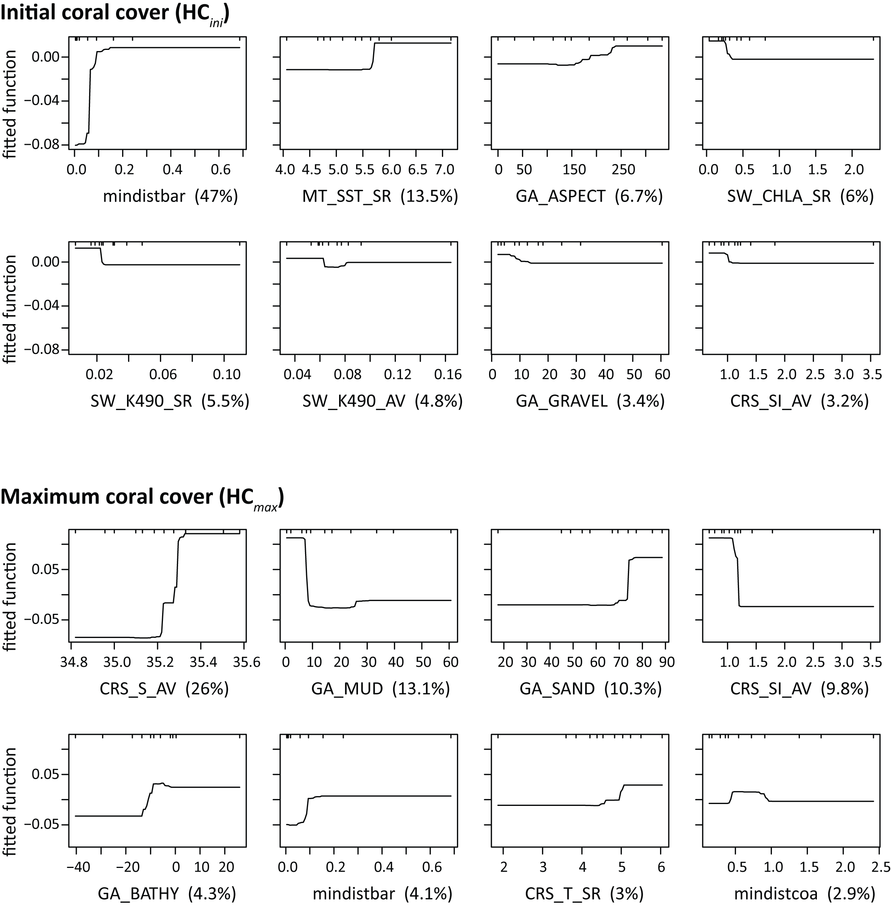

Figure S1. Partial effects for boosted regression trees predicting initial coral cover (top) and maximum coral cover (bottom). For each response variable, partial effects (‘fitted function’) are shown for the eight most important predictors only, with the relative importance of each predictor (%) indicated in brackets. See Table S1 for variable codes.

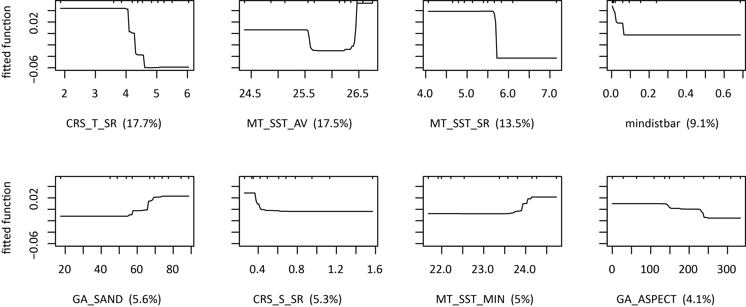

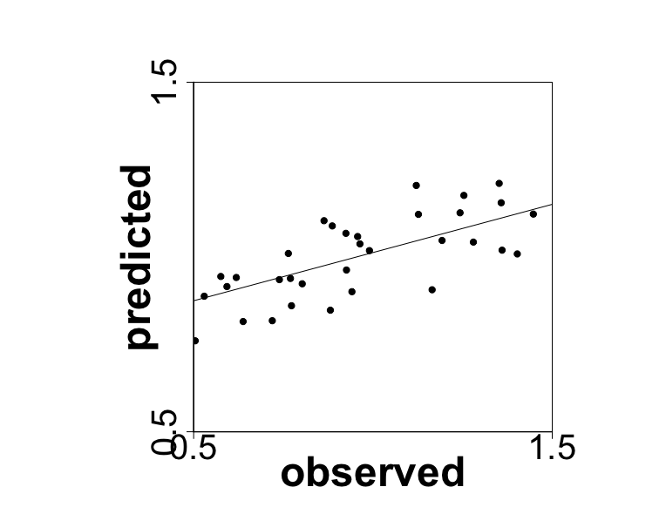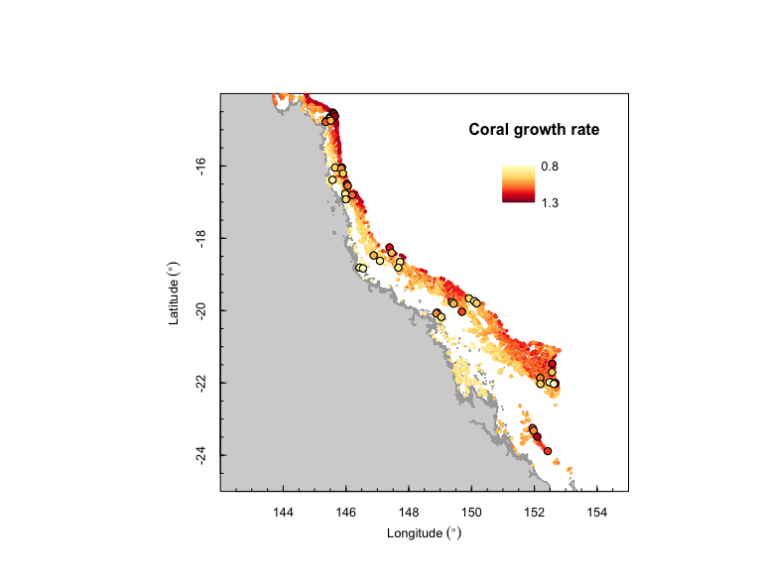

Figure S2 Prediction of coral intrinsic growth rate (). Top panel: partial effects of the eight most important predictors in boosted regression trees, with the relative importance of each predictor (%) indicated in brackets. See Table S1 for variable codes. Bottom panel: BRT predictions of across the Great Barrier Reef. Dots show observations used for model calibration (based on MacNeil et al. in prep). The insert shows the regression of BRT predictions against observations (*R*2 = 0.71, *P* < 0.001).

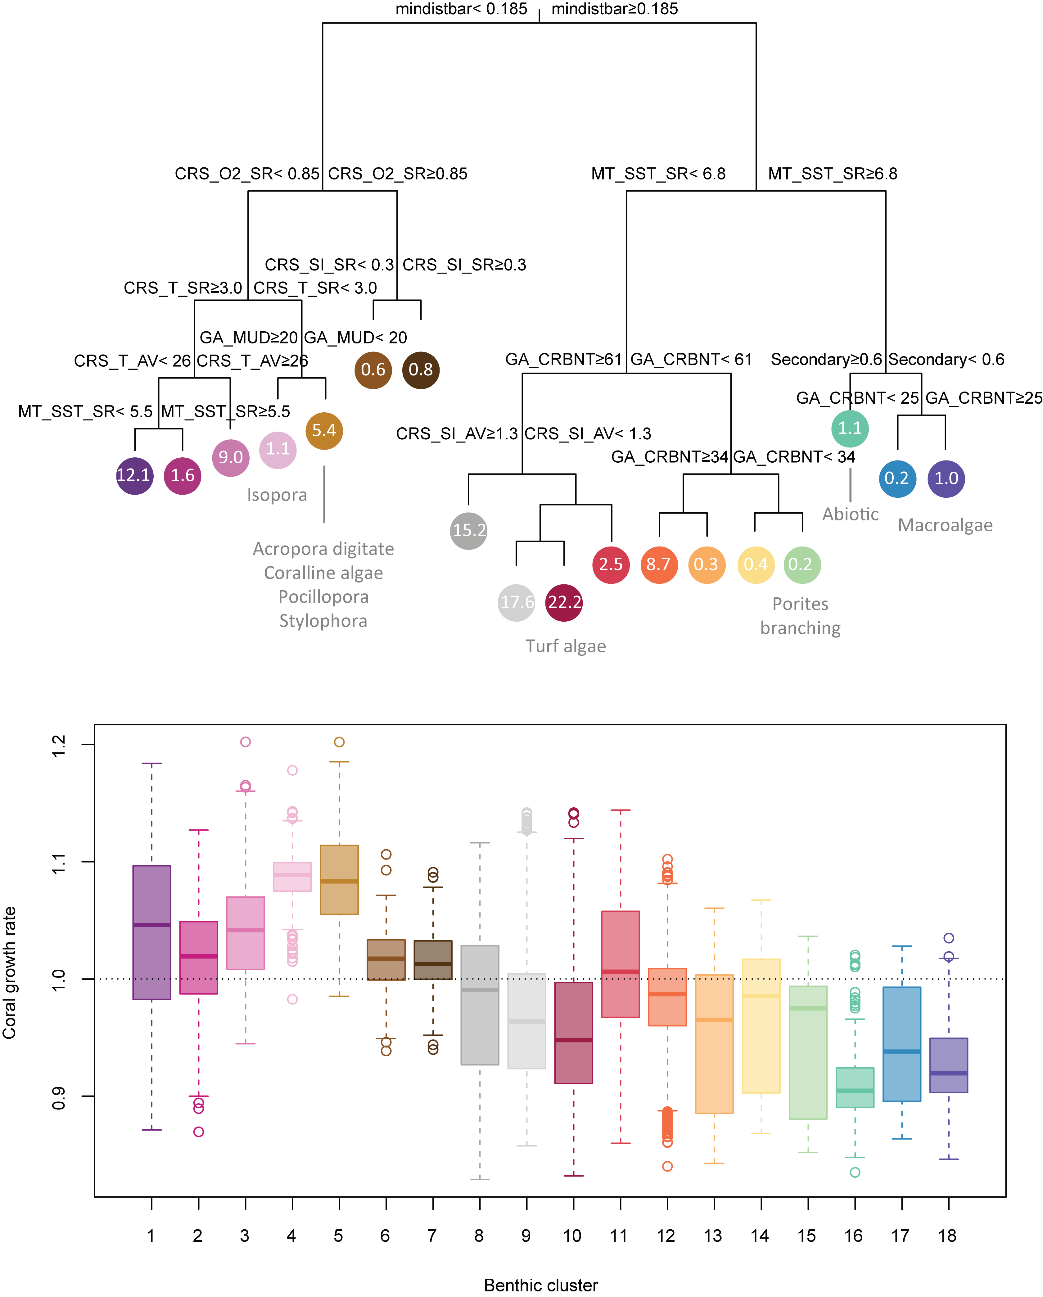

Figure S3. Multivariate regression tree predicting benthic community composition as a function of environmental and spatial variables on the Great Barrier Reef. Top panel: a total of 15 benthic communities were defined by splitting all samples (N = 46) based on environmental predictors (only the most important predictors are shown for clarity; see Table S1 for variable codes). Indicated are the proportion of each community on the GBR (%) and, where applicable, indicator taxa identified based on the Dufrêne-Legendre index. Bottom panel: coral intrinsic growth rates () predicted by BRT for each community. The thick line indicates the median, hinges the interquartile range, whiskers the 90% confidence interval and dots show outliers.

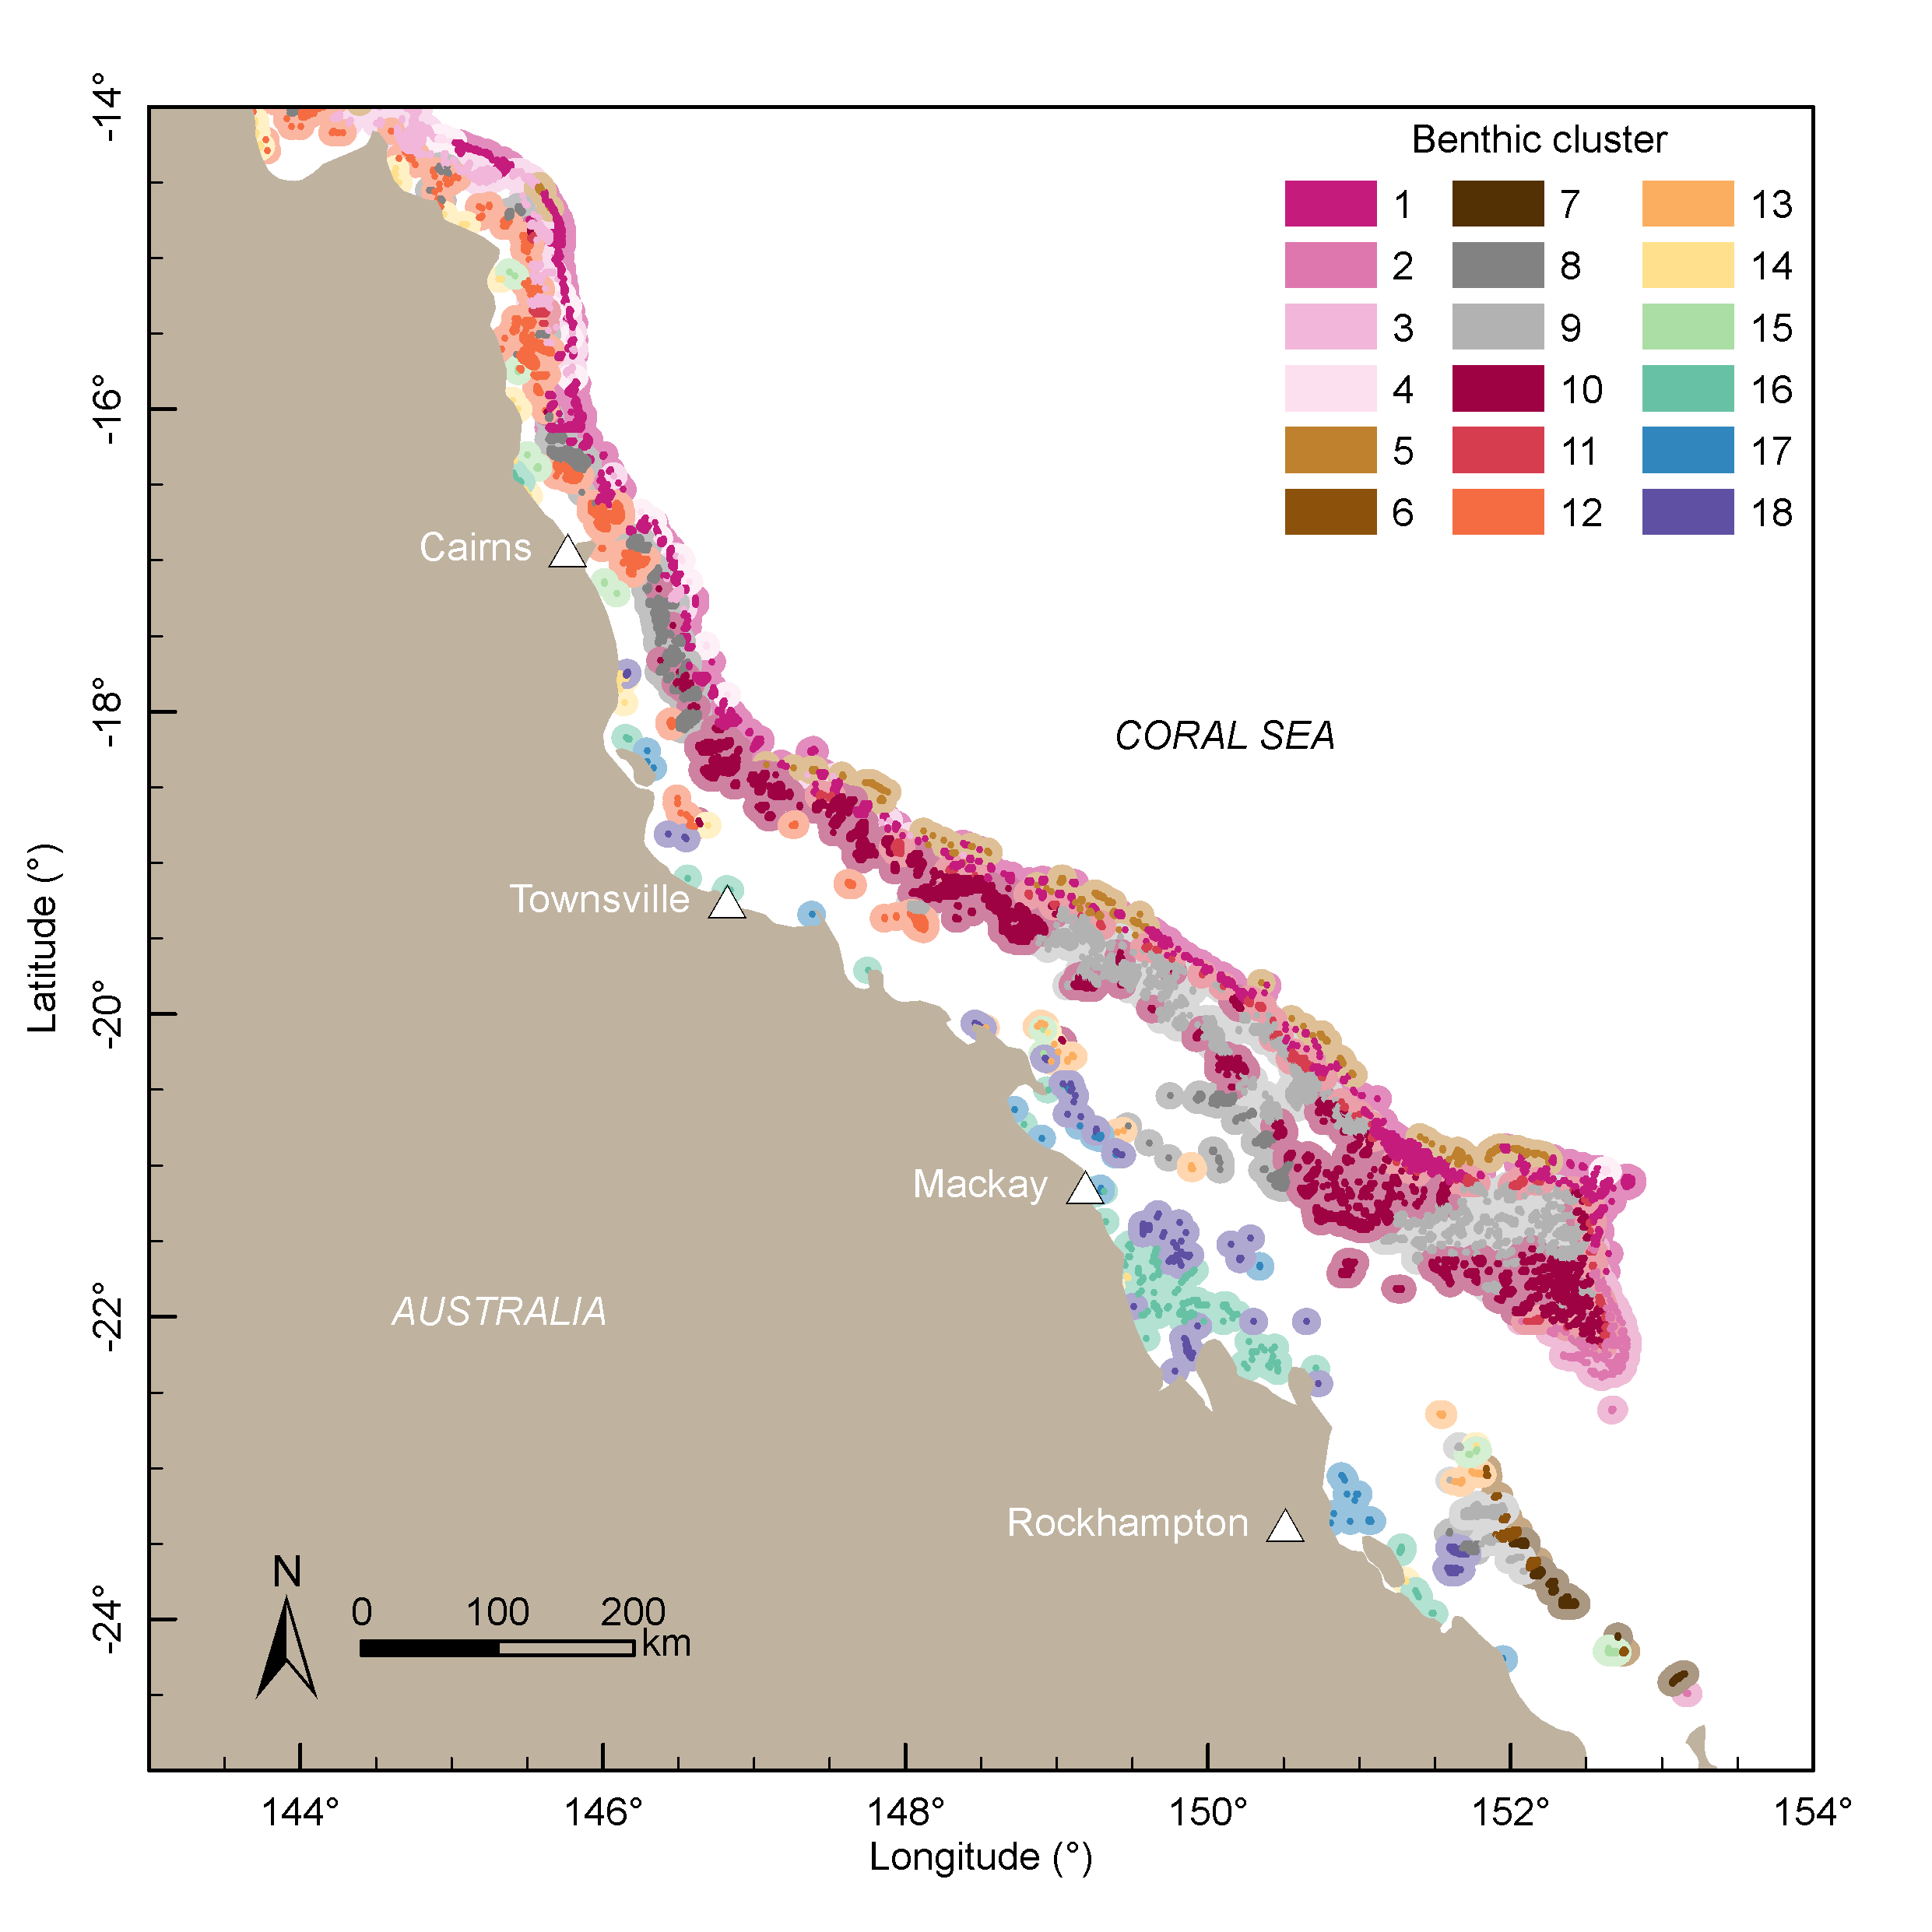

Figure S4 Benthic clusters predicted across the Great Barrier Reef by multivariate regression trees. See Fig. S3 for environmental variables, indicator taxa and coral growth rate associated with each cluster.

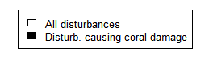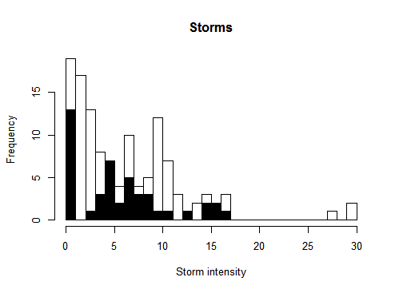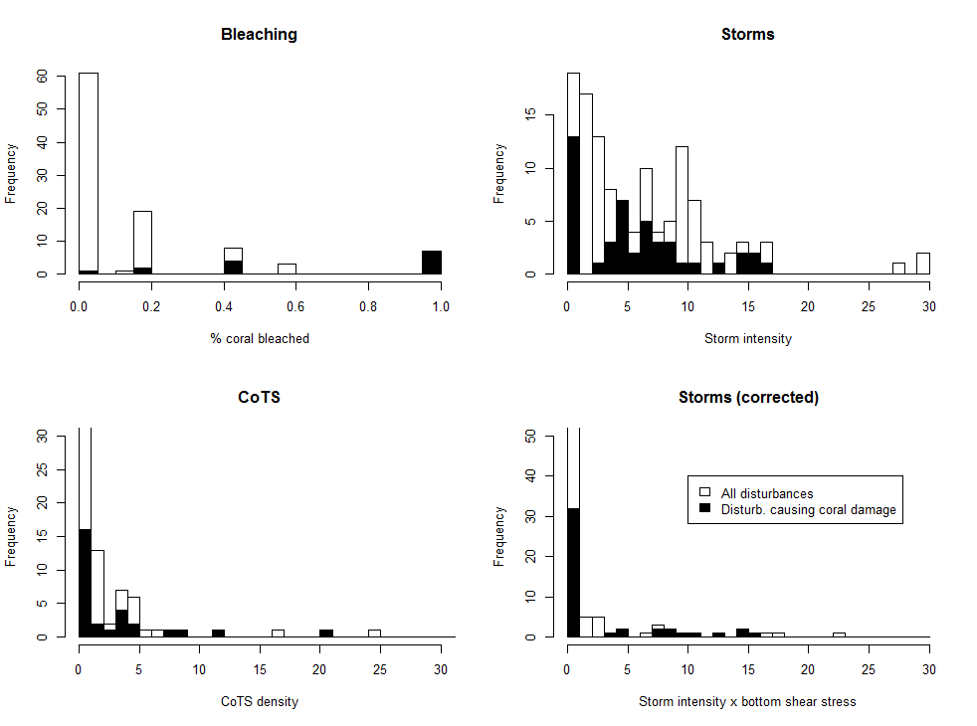

Figure S5. Histograms showing the distribution of disturbance severity for all recorded disturbances (white bars) and those associated with actual coral loss in the LTMP validation dataset (black bars) for bleaching, cyclones and outbreaks of the crown-of-thorns starfish (CoTS) *Acanthaster planci*.

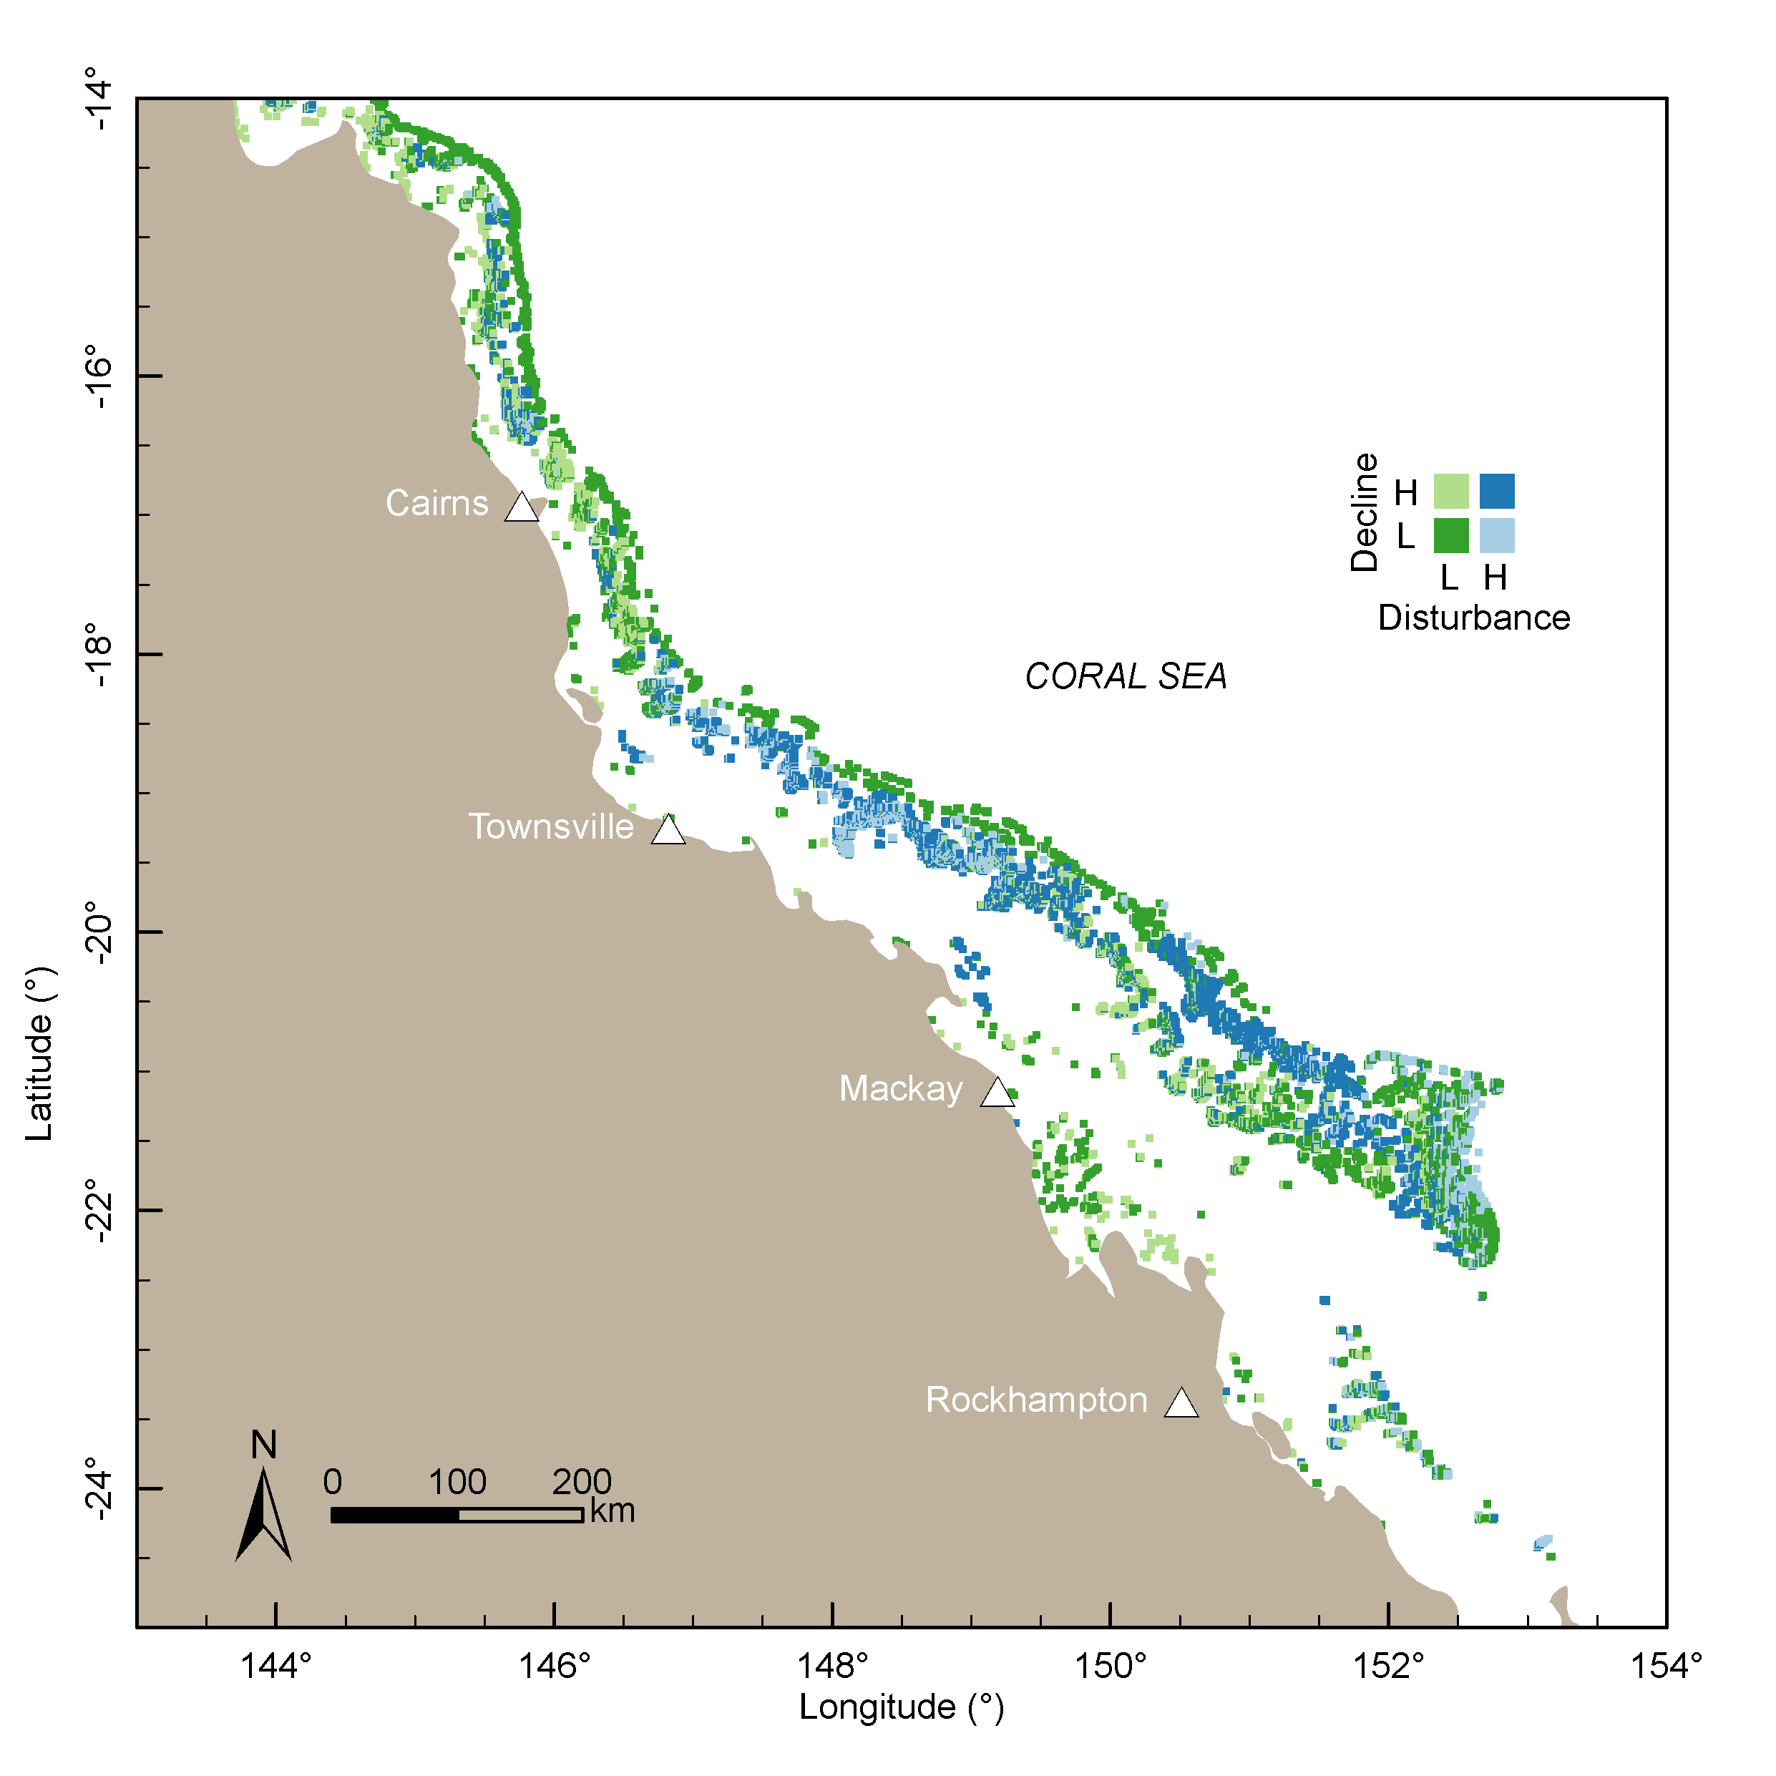

Figure S6. Spatial patterns in the predicted extent of decline in coral cover (i.e. with high decline corresponding to low, negative change in coral cover) and disturbance severity (i.e. the combined severity of all coral bleaching events, *A. planci* outbreaks, and cyclones recorded over the study period, and weighted by their effect size). For both variables, low and high categories corresponded to values below and above the median respectively.

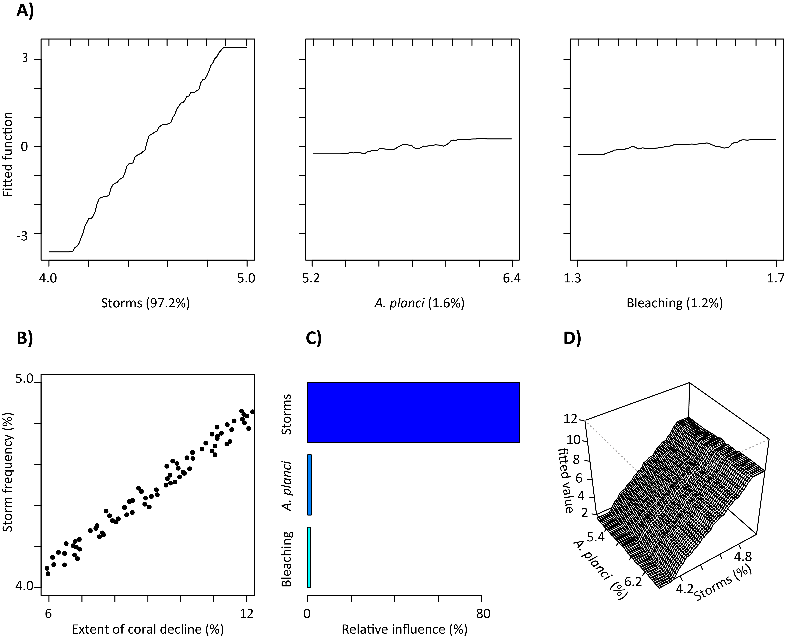

Figure S7. Sensitivity analysis quantifying the importance of disturbance frequency on predicted coral decline. **(A)** Boosted regression tree partial effects showing the influence of disturbance frequency (%) for cyclones (left), *Acanthaster planci* outbreaks (middle) and bleaching (right) on the extent of predicted coral decline across the Great Barrier Reef. The relative importance of each disturbance type (%) is indicated in brackets. **(B)** Scatter plot showing the mean extent of predicted coral decline across the Great Barrier Reef (%) as a function of cyclone frequency (%). **(C)** Relative influence (%) of the frequency of each disturbance on predicted coral decline across the Great Barrier Reef. **(D)** Interaction between cyclones and *A. planci* outbreak frequencies and its effect of the extent of predicted coral decline.

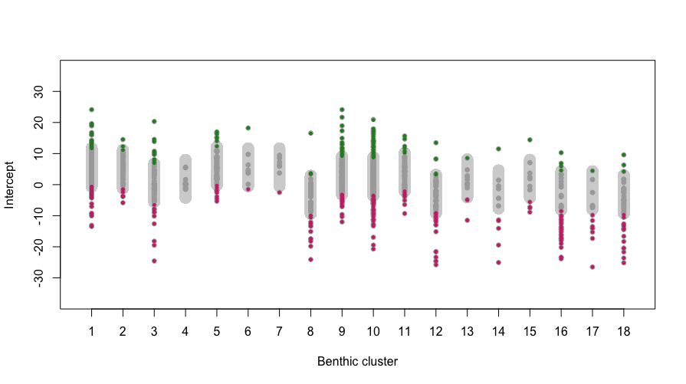

Figure S8 Identification of bright (green) and dark (magenta) spots based on cluster- and reef-level random intercepts. For each benthic cluster along the *x* axis, the grey interval represents the 2-standard deviation (2SD) around the cluster-level intercept. The reefs for which the intercept was above or below the 2SD cluster-level prediction interval (grey) were defined as bright (green) or dark (magenta) spots respectively.

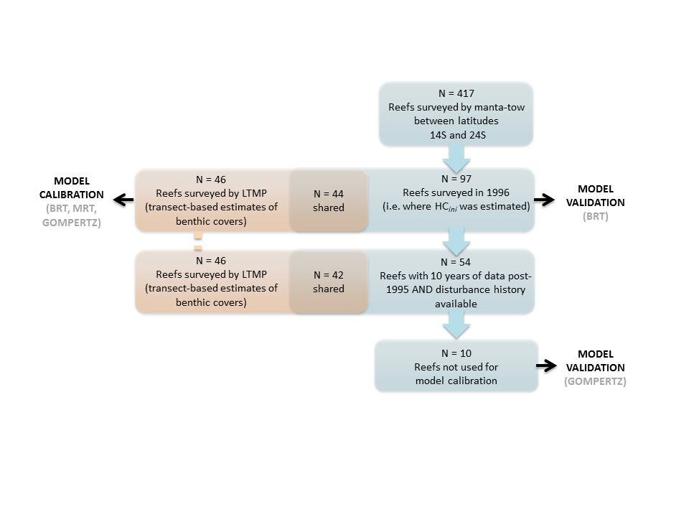

Figure S9. Flow chart of sample sizes used at each step of the model development.